

**Activity based**

**Project 1 Report on**

**Application Security**

**Submitted to Vishwakarma University, Pune**

**Under the Initiative of**

**Contemporary Curriculum, Pedagogy, and Practice (C2P2)**

**By**

**Student Name : Alfiya Javed Sayyed**

**SRN No : 202202232**

**Roll No : 58**

**Div : F**

**Second Year Engineering**

**Department of Computer Engineering**

**Faculty of Science and Technology**

**Academic Year**

**2023-2024**

**Project Statement:**

Pizza House wants to enable a uploading a wide variety of files through its website. However, they fear that someone could upload an infected file that could damage their systems. Implement a file upload functionality that employs the use of an antivirus checking API to ensure safety.

**Design (Usecase Model, ER Model, DFDs):**

Actors:

Customer

Use Cases:

View Menu

Actor: Customer

Description: Allows the customer to view the pizza menu.

Preconditions: None

Postconditions: The customer can see the menu.

Trigger: Customer accesses the menu page.

Order from Menu

Actor: Customer

Description: Allows the customer to place an order from the menu.

Preconditions: Customer has viewed the menu.

Postconditions: The order is placed successfully.

Trigger: Customer clicks on the "Order from Menu" button.

Order Your Cravings

Actor: Customer

Description: Allows the customer to order their cravings.

Preconditions: None

Postconditions: The order is placed successfully.

Trigger: Customer clicks on the "Order Your Cravings" button.

Upload Image for Scan

Actor: Customer

Description: Allows the customer to upload an image file for scanning.

Preconditions: None

Postconditions: The image is uploaded for scanning.

Trigger: Customer accesses the upload page.

Scan Image

Actor: Customer

Description: Initiates the scan process for the uploaded image.

Preconditions: Customer has uploaded an image.

Postconditions: The image is scanned for viruses.

Trigger: Customer submits the uploaded image for scanning.

View Order Details

Actor: Customer

Description: Allows the customer to view the details of their order.

Preconditions: Customer has placed an order.

Postconditions: The customer can see the order details.

Trigger: Customer accesses the order details page.

Place Order

Actor: Customer

Description: Allows the customer to place the order after providing delivery details.

Preconditions: Customer has provided delivery details.

Postconditions: The order is successfully placed.

Trigger: Customer submits the delivery details.

Redirect to Order Page

Actor: Customer

Description: Redirects the customer to the order page after scanning the image.

Preconditions: Image scan is completed.

Postconditions: Customer is redirected to the order page.

Trigger: Customer clicks on the "Order" button after image scan.

This use case model outlines the various interactions between the customer and the Flask application, including viewing the menu, ordering pizzas, uploading images for scanning, and placing orders.

**Usecase Model:**

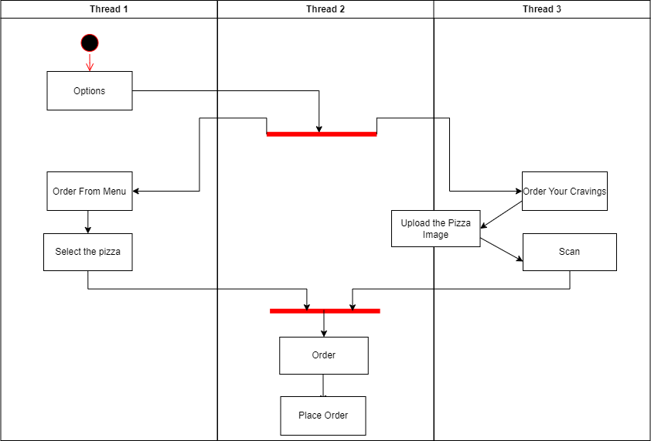

Figure 1-Use Case Model

**Implementation:**

from flask import Flask, request, jsonify, render_template_string, redirect, url_for

import requests

app = Flask(__name__)

@app.route('/menu', methods=['GET'])

def menu():

return """

<!DOCTYPE html>

<html lang="en">

<head>

<meta charset="UTF-8">

<meta name="viewport" content="width=device-width, initial-scale=1.0">

<title>Pizza Menu</title>

<style>

body {

font-family: 'Arial', sans-serif;

margin: 0;

padding: 0;

background: linear-gradient(135deg, #ff9999, #ffcc99, #ffef99, #ccff99, #99ff99); /* Color gradient resemblin>

}

.container {

max-width: 1200px;

margin: 0 auto;

padding: 20px;

position: relative;

}

h1 {

text-align: center;

color: #fff;

text-shadow: 2px 2px 4px rgba(0, 0, 0, 0.5); /* Adding a shadow effect to the text */

}

.pizza-menu {

display: flex;

justify-content: space-between;

flex-wrap: wrap;

}

.pizza-item {

width: calc(33.33% - 20px);

margin-bottom: 20px;

box-sizing: border-box;

position: relative;

background-color: rgba(255, 255, 255, 0.8); /* Adding a semi-transparent white background */

padding: 20px;

border-radius: 10px;

}

.pizza-item h2 {

margin-top: 0;

font-family: 'Georgia', serif; /* Changing font family */

color: #333;

}

.pizza-img {

width: 100%;

height: auto;

border-radius: 10px;

box-shadow: 0 0 10px rgba(0, 0, 0, 0.2); /* Adding a shadow effect to the images */

}

.price {

position: absolute;

bottom: 10px;

left: 10px;

font-size: 18px;

color: #333;

}

.add-to-cart {

background-color: #4CAF50;

color: white;

padding: 10px 20px;

border: none;

cursor: pointer;

border-radius: 5px;

font-size: 16px;

position: absolute;

bottom: 10px;

right: 10px;

}

.add-to-cart:hover {

background-color: #45a049; /* Darker shade on hover */

}

.cart {

position: fixed;

top: 20px;

right: 20px;

background-color: #f44336;

color: white;

padding: 10px 20px;

border: none;

cursor: pointer;

border-radius: 50%

z-index: 2; /* Ensure cart is above the content */

}

.cart-count {

position: absolute;

top: 5px;

right: 10px;

background-color: white;

color: #f44336;

border-radius: 50%;

width: 20px;

height: 20px;

text-align: center;

line-height: 20px;

}

.cart-overlay {

position: fixed;

top: 0;

left: 0;

width: 100%;

height: 100%;

background-color: rgba(0, 0, 0, 0.5); /* Semi-transparent black background */

display: none;

justify-content: center;

align-items: center;

z-index: 3; /* Ensure overlay is above everything */

}

.cart-content {

background-color: #fff;

padding: 20px;

border-radius: 10px;

}

.cart-item {

margin-bottom: 10px;

}

.cart-item-info {

display: flex;

justify-content: space-between;

}

.cart-item-name {

flex-grow: 1;

}

.cart-item-price {

margin-left: 10px;

}

.cart-item-actions {

display: flex;

align-items: center;

}  
 .cart-item-action {

margin-left: 10px;

cursor: pointer;

}

.close-cart {

position: absolute;

top: 10px;

right: 10px;

cursor: pointer;

}

.order-now-button {

background-color: #4CAF50;

color: white;

padding: 10px 20px;

border: none;

cursor: pointer;

border-radius: 5px;

font-size: 16px;

margin-top: 20px;

}

</style>

</head>

<body>

<div class="container">

<h1>Pizza Menu</h1>

<div class="pizza-menu">

<div class="pizza-item">

<h2>Chicago Style Pizza</h2>

<div class="price">₹400</div>

<button class="add-to-cart" onclick="addToCart('Chicago Style', 400)">Add to Cart</button>

</div>

<div class="pizza-item">

<h2>Brick Oven Pizza</h2>

<div class="price">₹420</div>

<button class="add-to-cart" onclick="addToCart('Brick Oven', 420)">Add to Cart</button>

</div>

<div class="pizza-item">

<h2>Italian Pizza</h2>

<div class="price">₹400</div>

<button class="add-to-cart" onclick="addToCart('Italian', 400)">Add to Cart</button>

</div>

<div class="pizza-item">

<h2>Neapolitan Pizza</h2>

<div class="price">₹490</div>

<button class="add-to-cart" onclick="addToCart('Neapolitan', 490)">Add to Cart</button>  
 </div>

<div class="pizza-item">

<h2>New York Style Pizza</h2>

<div class="price">₹470</div>

<button class="add-to-cart" onclick="addToCart('New York Style', 470)">Add to Cart</button>

</div>

<div class="pizza-item">

<h2>Sicilian Pizza</h2>

<div class="price">₹460</div>

<button class="add-to-cart" onclick="addToCart('Sicilian', 460)">Add to Cart</button>

</div>

<div class="pizza-item">

<h2>Greek Pizza</h2>

<div class="price">₹430</div>

<button class="add-to-cart" onclick="addToCart('Detroit', 430)">Add to Cart</button>

</div>

<div class="pizza-item">

<h2>Greek Pizza</h2>

<div class="price">₹410</div>

<button class="add-to-cart" onclick="addToCart('Greek', 410)">Add to Cart</button>

</div>

</div>

<div class="cart" onclick="toggleCart()">

<span class="cart-count">0</span>

&#128722; <!-- Cart icon -->

</div>

<div class="cart-overlay" onclick="toggleCart()">

<div class="cart-content">

<span class="close-cart" onclick="toggleCart()">&times;</span>

<h2>Cart</h2>

<div id="cartItems"></div>

<a href="/order/<scan_id>"><button class="order">Place Order</button></a>

</div>

</div>

</div>

<script>

let cart = [];

const cartCount = document.querySelector('.cart-count');

function addToCart(pizzaName, price) {

cart.push({ name: pizzaName, price: price });

updateCartCount();

}

function updateCartCount() {

cartCount.textContent = cart.length;

}

function toggleCart() {

const overlay = document.querySelector('.cart-overlay');

overlay.style.display = overlay.style.display === 'flex' ? 'none' : 'flex';

// Update cart items

const cartItemsContainer = document.getElementById('cartItems');

cartItemsContainer.innerHTML = '';

cart.forEach(item => {

const cartItem = document.createElement('div');

cartItem.classList.add('cart-item');

const cartItemInfo = document.createElement('div');

cartItemInfo.classList.add('cart-item-info');

const cartItemName = document.createElement('div');

cartItemName.classList.add('cart-item-name');

cartItemName.textContent = item.name;

const cartItemPrice = document.createElement('div');

cartItemPrice.classList.add('cart-item-price');

cartItemPrice.textContent = '₹' + item.price;

const cartItemActions = document.createElement('div');

cartItemActions.classList.add('cart-item-actions');

const deleteButton = document.createElement('span');

deleteButton.classList.add('cart-item-action');

deleteButton.textContent = '❌';

deleteButton.onclick = function() {

removeFromCart(item);

};

cartItemActions.appendChild(deleteButton);

cartItemInfo.appendChild(cartItemName);

cartItemInfo.appendChild(cartItemPrice);

cartItem.appendChild(cartItemInfo);

cartItem.appendChild(cartItemActions);

cartItemsContainer.appendChild(cartItem);

});

}

function removeFromCart(item) {

const index = cart.findIndex(cartItem => cartItem.name === item.name);

if (index !== -1) {

cart.splice(index, 1);

updateCartCount();

toggleCart();

}

}

</script>

</body>

</html>

"""

@app.route('/', methods=['GET'])

def home():

return """

<!DOCTYPE html>

<html lang="en">

<head>

<meta charset="UTF-8">

<meta http-equiv="X-UA-Compatible" content="IE=edge">

<meta name="viewport" content="width=device-width, initial-scale=1.0">

<title>Options</title>

<style>

body {

font-family: Arial, sans-serif;

margin: 0;

padding: 0;

overflow: hidden;

justify-content: center; /* Horizontally center the contents */

align-items: center;

}

.content {

display: flex;

align-items: center;

height: 100vh;

background: linear-gradient(135deg, #ff9999, #ffcc99, #ffef99, #ccff99, #99ff99);

}  
 .content .text {

width: 50%;

color: white;

padding: 50px;

}

.content .text h1 {

font-size: 48px;

font-family: 'Segoe UI', Tahoma, Geneva, Verdana, sans-serif;

font-weight: bold;

text-align: center;

margin-bottom: 10px;

}

.content .text .subtitle {

font-size: 36px;

font-weight: bold;

margin-bottom: 10px;

text-align: center;

}

.content .text p {

font-size: 24px;

margin-bottom: 20px;

text-align: center;

}

.order-btn {

background-color: #333;

color: #fff;

padding: 10px 20px;

border: none;

border-radius: 5px;

font-size: 18px;

cursor: pointer;

transition: background-color 0.3s;

text-decoration: none;

display: inline-block;

}

.order-btn:hover {

background-color: #555;

}  
 </style>

</head>

<body>

<div class="content">

<div class="text">

<h1 style="font-family: 'Garamond', serif;">Da Wheely Good Pizza</h1>

<p class="subtitle">More Toppings, Less crust!</p>

<a href="/menu"><button class="order-btn">Order from Menu</button></a>

</body>

<a href="/upload"><button class="order-btn">Order Your Cravings</button></a>

</div>

</body>

</html>

"""

@app.route('/upload', methods=['GET', 'POST'])

@app.route('/upload', methods=['GET', 'POST'])

def index():

if request.method == 'GET':

return """

<!DOCTYPE html>

<html lang="en">

<head>

<meta charset="UTF-8">

<meta name="viewport" content="width=device-width, initial-scale=1.0">

<title>VirusTotal Scan</title>

</head>

<body>

<h1>Upload an Image File</h1>

<form action="/upload" method="post" enctype="multipart/form-data">

<input type="file" name="file" id="fileInput" accept="image/*">

<button type="submit">Upload</button>

</form>

<p id="scanId"></p>

<script>

function displayScanId(scanId) {

document.getElementById('scanId').innerText = "Scan ID: " + scanId;

}

</script>

</body>

</html>  
 """

elif request.method == 'POST':

api_key = 'b7131e2c868a0cfbb195c839044d224770db08aa60a8bacb2cc340bdbc6129ef'

file = request.files['file']

url = 'https://www.virustotal.com/vtapi/v2/file/scan'

params = {'apikey': api_key}

response = requests.post(url, files={'file': file}, params=params)

if response.status_code == 200:

json_response = response.json()

scan_id = json_response.get('scan_id')

return render_template_string(f"""

<!DOCTYPE html>

<html lang="en">

<head>

<meta charset="UTF-8">

<meta name="viewport" content="width=device-width, initial-scale=1.0">

<title>VirusTotal Scan</title>

</head>

<body>

<h1>Upload an Image File</h1>

<form action="/upload" method="post" enctype="multipart/form-data">

<input type="file" name="file" id="fileInput" accept="image/*">

<button type="submit">Upload</button>

</form>

<p id="scanId">Scan ID: {scan_id}</p>

<button id="orderButton" onclick="redirectToOrder()">Order</button>

<script>

displayScanId('{scan_id}');

function redirectToOrder() {{

window.location.href = '{url_for("order_page", scan_id=scan_id)}';

}}

</script>

</body>

</html>

""")

else:

return jsonify({'error': 'Failed to scan file'})

@app.route('/order/<scan_id>', methods=['GET'])

def order_page(scan_id):

pizza_name = "Your Pizza Name"

total_amount = 100 # Example total amount

return f"""

<!DOCTYPE html>

<html lang="en">

<head>

<meta charset="UTF-8">

<meta name="viewport" content="width=device-width, initial-scale=1.0">

<title>Order Page</title>

<style>

/* CSS styles for order page */

/* Paste the CSS styles from the order.html file here */

</style>

</head>

<body>

<div class="container">

<h1>Order Details</h1>

<div class="order-details">

<h2>Pizza Order</h2>

<p>Pizza: <span id="pizzaName">{pizza_name}</span></p>

<p>Total Amount: ₹<span id="totalAmount">{total_amount}</span></p>

<p>Tax (18%): ₹<span id="taxAmount">{total_amount * 0.18:.2f}</span></p>

<p>Grand Total: ₹<span id="grandTotal">{total_amount * 1.18:.2f}</span></p>

</div>

<div class="address-form">

<h2>Delivery Address</h2>

<form id="addressForm">

<label for="name">Name:</label>

<input type="text" id="name" name="name" required>

<label for="address">Address:</label>

<textarea id="address" name="address" required></textarea>

<button type="submit" class="place-order-button">Place Order</button>

</form>

</div>

</div>

<script>

// Form submission handler

document.getElementById('addressForm').addEventListener('submit', function(event) {{

event.preventDefault(); // Prevent default form submission

const formData = new FormData(this); // Get form data

// You can process the form data here (e.g., send it to a server)

// Display confirmation message

alert('Order confirmed! You will get your Pizza soon. Thank you!');

// Redirect to a thank you page or any other page as needed

window.location.href = 'thankyou.html';

}});

</script>

</body>

</html>

"""

if __name__ == '__main__':

app.run(debug=True)

**Results:**

**a)Home Page**

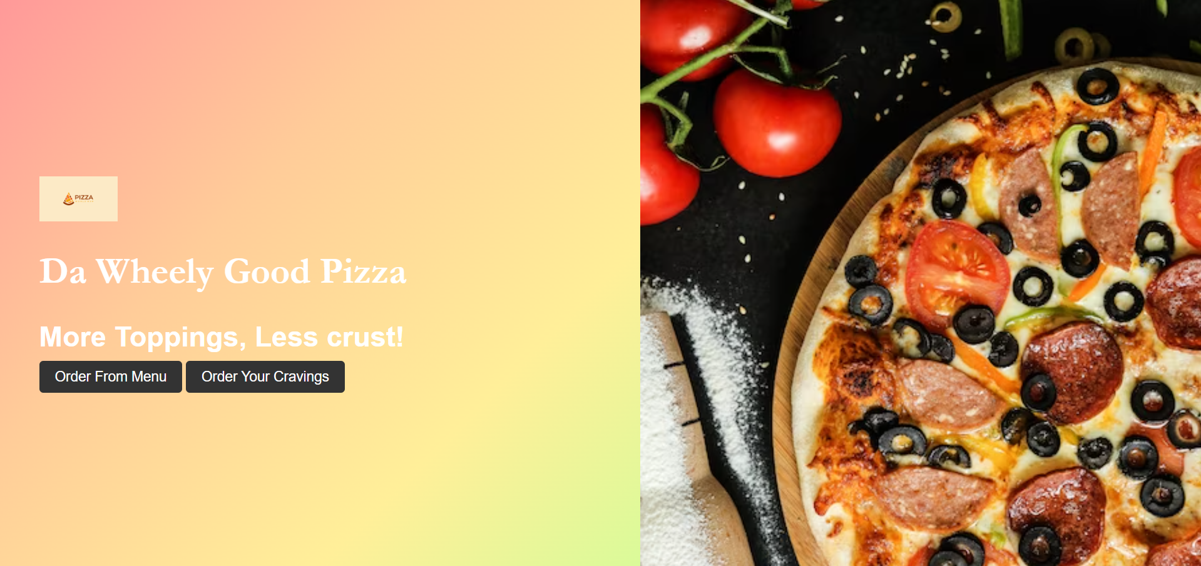

Figure 2-Home Page

When clicked on Order from Menu it will go to Menu page.

When clicked on Order Your Cravings it will go to Index page.

**b)Menu Page**

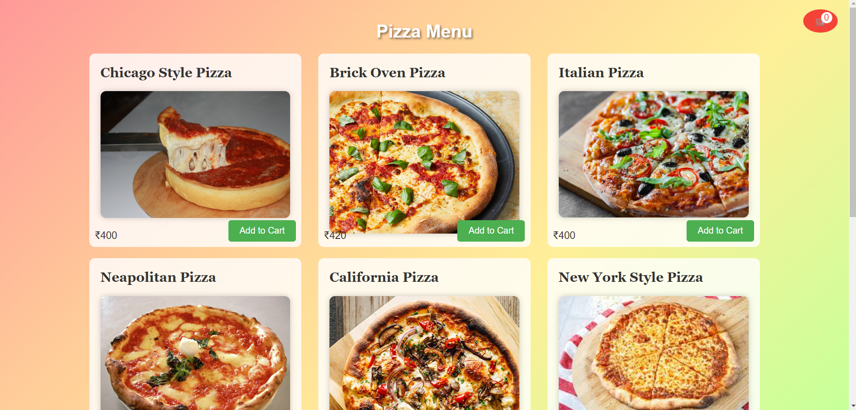

Figure 3-Menu Page(1)

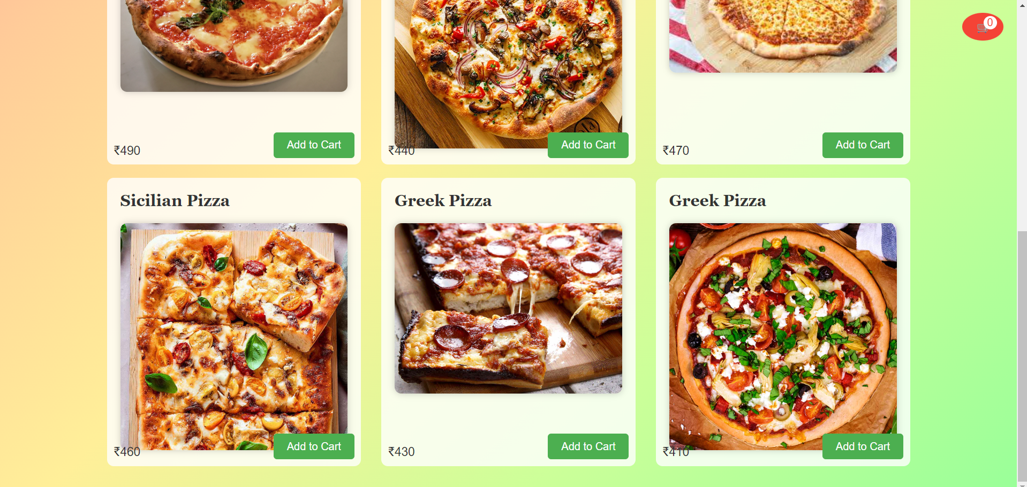

Figure 3-Menu page(2)

When user clicks on Add to Cart the cart number increments, and when we click on cart it will display the selected pizzas.

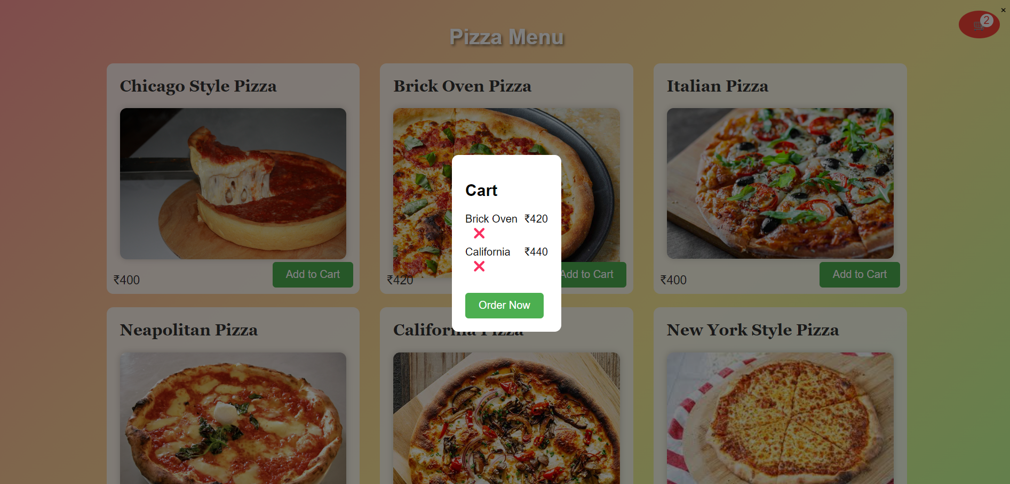

Figure 4-Cart items display

When user clicks on Order now it will go to Order page.

**c)Order Page**

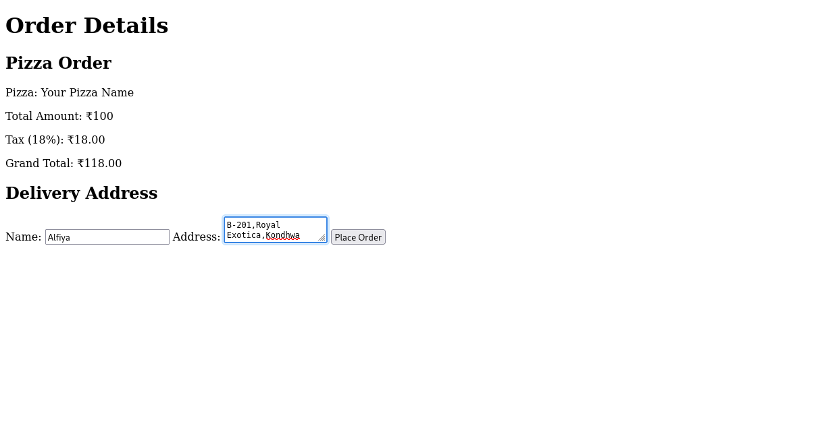

Figure 5-Order Page

When clicked on Place Order it will Pop up a Message.

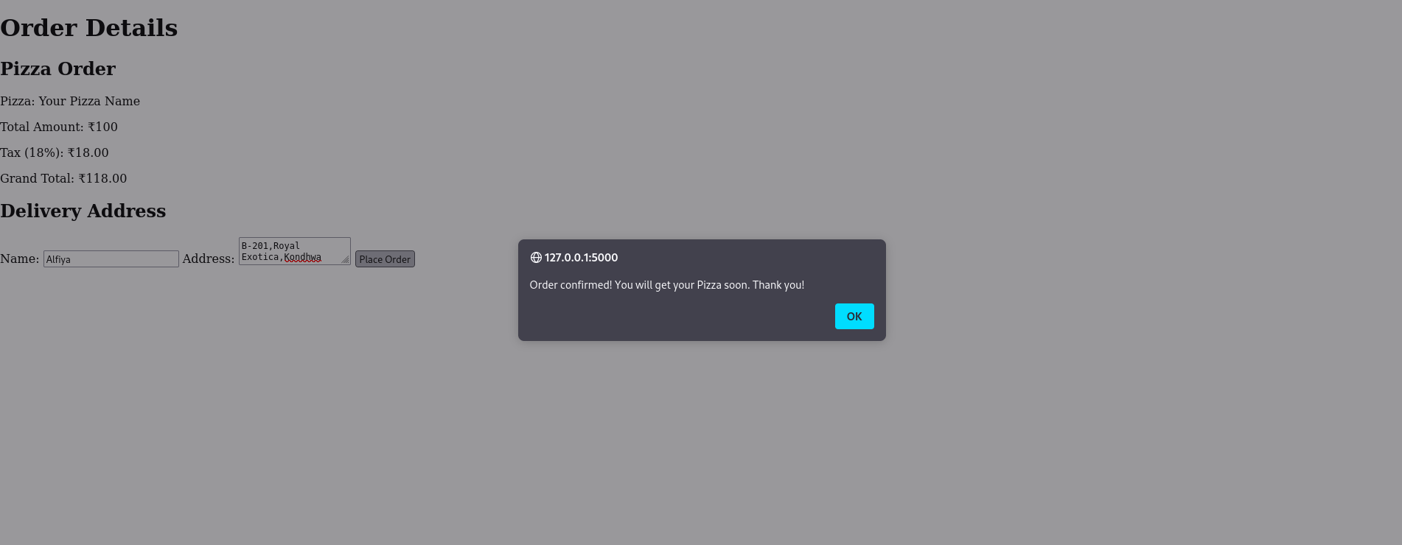

Figure 6-Pop Up.

**d)Index Page**

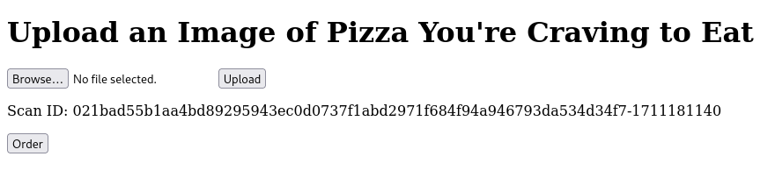

Figure 7-Index Page

The Scan id tells the status of the file if it is safe. **e)Scan Id checking in Api**

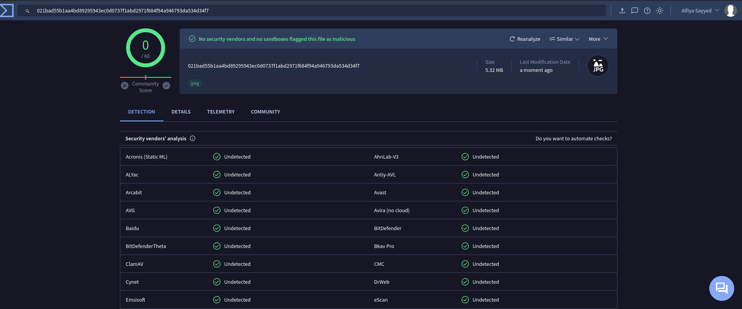

Figure 8-Scan Id checking in Api

It is a safe Image. When clicked on Order It will go to the order page.

**f)Order Page**

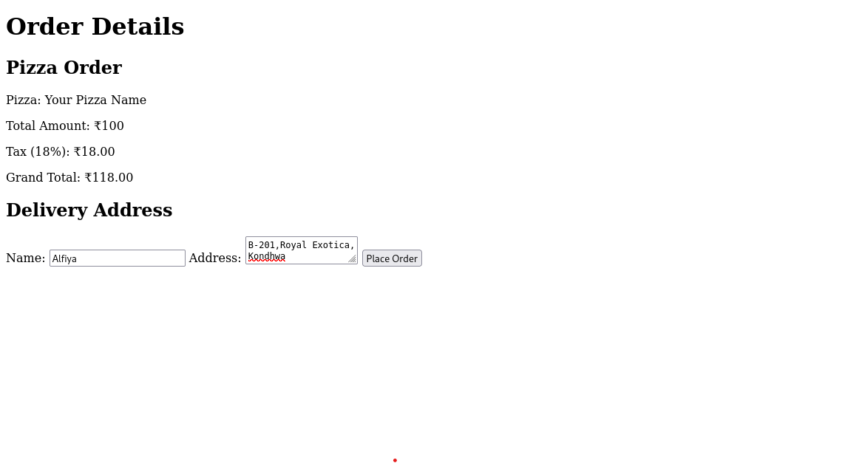

Figure 9-Order Page

When clicked on Place Order it will Pop up a Message.

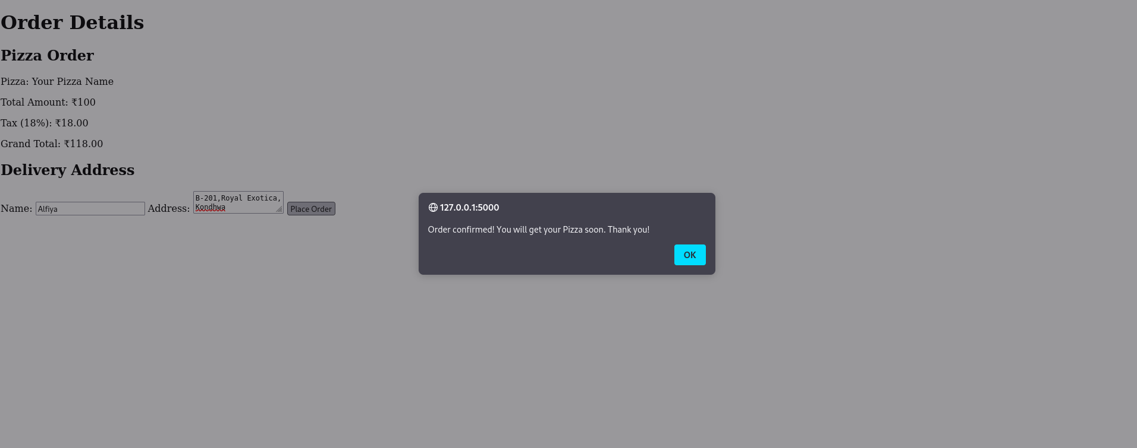

Figure 10-Pop Up.

**Conclusion :**

The project involves the development of a secure file upload functionality for Pizza House's website to prevent potential threats from infected files. Utilizing Flask framework and various web technologies, the application allows customers to browse the menu, place orders, and upload images for scanning using an antivirus checking API. Integration with VirusTotal API enhances security by verifying the safety of uploaded images. Additionally, Firebase Authentication system ensures secure user registration and login, with features like email verification and password recovery. Overall, the project highlights the importance of prioritizing security measures in digital platforms for a safe and enjoyable user experience.